CHAPTER - 2

DESIGN AND IMPLEMENTATION

2.1 KKSHELL ALGORITHM

- Start the shell
- The function login confirms User name and Password.
- KKShell prompt is displayed.
- The command is accepted using lexer.
- The function yylex() is used to get the command name from the command, the command name is compared with the string and the respective function is called to perform the operation.
- If this fails the default module is called which displays the error message.
- The function getargs is used to get the arguments after the command name.
- The command is executed and the KKSHELL prompt is displayed again.
- The logout function is used to logout from the shell.
- The kexit function is used to exit from KKSHELL.

The use of various APIs and other built in function help make the implementation of many commands hassle free. Many global variables and also a few built – in structures help make operations on files, directories etc very simple.

Although most of the commands people type on the prompt are the name of other UNIX programs, shells recognize some special commands which are not program names. For example, the exit command terminates the shell, and the cd command changes the current working directory. Shells directly make system calls to execute these commands, instead of forking a child process to handle them.

2.2KKSHELL FLOW CHART

Enter into KKSHELL

Username & Password

Display the KKSHELL
prompt

Accept the Command
Call the corresponding function
logout
kexit
Other functions
getargs
yylex
Exit from KKSHELL

fig 2.1
2.3 HEADER FILES

HEADER FILE  <stdio.h>  <string.h>  <time.h>  <dirent.h>  <ctype.h>  <stdlib.h>  <pwd.h>  <fcntl.h>  <sys/types.h>  <sys/stat.h>  <sys/wait.h>  <sys/utsname.h> | DESCRIPTION  Includes standard I/O library.  Includes string operations.  Includes time and date.  Includes directory entries.  Includes character types.  Includes utility files.  Includes password files.  Include file control.  Includes primitive system data types.  Includes file status.  Includes process control.  Includes system name.
fig 2.2

2.4 KKSHELL COMMANDS

kdate
Display date and time

Syntax
kdate

Implementation
This command is implemented using time.h header file. time(0) is used to get time.

kmd
Create a new directory

Syntax
kmd [dirname]

Implementation
This is implemented using mkdir() system call. If the return value is 0 then the directory is created successfully.

krd
Remove a directory

Syntax
krd [dirname]

Implementation
This is implemented using rmdir() system call. If the return value is 0 then the directory is removed successfully.

kren
Rename directories and files

Syntax
kren [old name] [new name]

Imlementation
This is implemented using rename() system call which takes arguments in the above format. If the return value is 0 then the file/dir is renamed successfully.

kcat
Display the contents of a file

Syntax
kcat [-p] [filename]

Implementation
This is implemented using fopen(). The specified file is opened in read mode. Its contents are displayed using fgetc() and printf()

The option –p is used to display the contents of file page wise.

kls
List all files and directories

Syntax
kls [-p] [path]

Implementation
This is implemented using opendir() and readdir() system calls. The files and directories are listed of the path if specified else contents of present working directory is displayed.

The option –p is used for listing page wise.

kclear
Clears the screen

Syntax
kclear

kpwd
Display present working directory

Syntax
kpwd

Implementation
This is implemented using getcwd() system call which accept path length as parameter.

kwc
Display the no of lines, words and characters in a file.

Syntax
kwc [filename]

Implementation
This is implemented by opening the file in read mode and then comparing characters with newline(\n) and spaces.

khead
Display n lines from beginning of the file.

Syntax
khead [file name] [no of lines]

Implementation
This is implemented by opening the file in read mode. By maintaining a count variable the specified no of lines are printed using printf().If no of lines are not specified then by default 10 lines are displayed

ktail
Display n lines from bottom of the file.

Syntax
ktail [file name] [no of lines]

Implementation
This is implemented by opening the file in read mode. By maintaining a count variable the specified no of lines are printed using printf(). If no of lines are not specified then by default 10 lines are displayed

kwhoami
Display the login name

Syntax
kwhoami

Implementaion
This is implemented using getpwuid() system call. This system call accepts uid no as parameter which is got by using getuid() system call.

kuname
Display OS, OS release, Version of Release and Hardware Type

Syntax
kuname

Implementation
This is implemented using uname() system call which accept utsname structure variable as parameter.

kcp
Copy contents of one file to another file.

Syntax
kcp [source file] [destination file]

Implementation
This is implemented by opening source file in read mode and destination file in write mode. The functions fgetc() and fputc() are used to read and write characters onto file respectively.

kcd
Change the present working directory

Syntax
kcd [directory path]

Implementation
This is implemented by using chdir() system call. The return value is -1 in case of error in changing directory.

kecho
Display a line of text

Syntax
kecho [string]

Implementation
This is implemented by using printf() and a for loop.

kman
Get summary of commands

Syntax
kman

about
Display about the programmers

Syntax
about

logout
logout from KKSHELL

Syntax
logout

exit
exit from KKSHELL

Syntax
exit

kvi
invokes the editor

Syntax
kvi

CHAPTER 5
SNAPSHOTS

CHAPTER 6
TESTING

Introduction: Software testing is an important element of software quality of specification design and coding. Testing is a process of executing a program with the intend of finding an error.

Types of Testing:

System Testing: Testing is the final phase of the software development and also it is one of the important steps in software Engineering. Where the quality and the reliability of the product is determined. After the system has been satisfactorily coded, the product must be undergoing for a testing process.Testing should satisfy all requirements specified in the software requirements specification document. After the success of testing it needs to be implemented.

Unit Testing: Unit testing is a test of a simple piece of code. As already mentioned, that the system has been developed by modules wise and the first phase of testing must be module wise testing Checking whether the module works independently and without any bugs and errors. Base module is tested first and then each module is being tested one after the other.

Integration Testing:
Integration testing is the next level. The module of the all modules system has been first taken and according to the linkage priority each modules have been all modules system has been first taken and according to the linkage priority each modules have been integrated into the system. This integration test is performed in order to verify that the system works according to the requirements even after integration of all modules system has been first taken and according to the linkage priority each modules have been

Performance Testing:
This testing is designed to test the run time performance of software within the integrated system. This system occurs throughout all steps in the testing process
Testing information flow: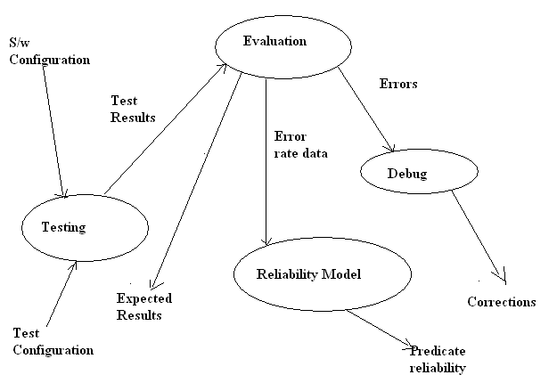

Unit testing:

TEST  CASE ID | TEST DESCRIPTION | TEST  DATA | RESULTS |  | REMARK
TEST  CASE ID | TEST DESCRIPTION | TEST  DATA | EXPECTED  RESULT | ACTUAL  RESULT | REMARK
Shell_01 | Function of KLS | kls | Display list of files and directories. | Display list of files and directories. | Pass
Shell_02 | Function of KWC | kwc | Counts number of words | Counts number of words | Pass
Shell_03 | Function of KDATE | kdate | Displays current system date | Displays current system date | Pass
Shell_04 | Function of KUNAME | kuname | Displays OS information | Displays OS information | Pass
Shell_05 | Function of KPWD | kpwd | Displays present working directory. | Displays present  Working directory | Pass
Shell_06 | Checks the function of KMD | kmd | Creates a new directory | Creates a new directory | Pass
Shell_07 | Function of KCD | kcd | Changes directory | Changes directory | Pass
Shell_08 | Function of KRD | krd | Removes directory | Removes directory | Pass
Shell_09 | Function of KCAT | kcat | Displays contents of a file | Displays contents of a file | Pass
Shell_10 | Function of HEAD | khead | Displays first ten lines of a file | Displays first ten lines of a file | Pass
Shell_11 | Function of TAIL | ktail | Displays last ten lines of a file | Displays last ten lines of a file | Pass
Shell_12 | Function of KVI | kvi | Invokes the editor | Invokes the editor | Pass
Shell_13 | Function of KCP | kcp | Copy contents of one file to other. | Copy contents of one file to other | Pass
Shell_14 | Function of  KREN | kren | Renames a specified file | Renames a specified file | Pass
Shell_15 | Function of KMAN | kman | Display summary of commands | Display summary of commands | Pass
Shell_16 | Function of KLSP | kls-p | Displays all files and directories in the specified path | Displays all files and directories in the specified path | pass
Shell_17 | Function of KCLEAR | kclear | Clears screen | Clears screen | pass

